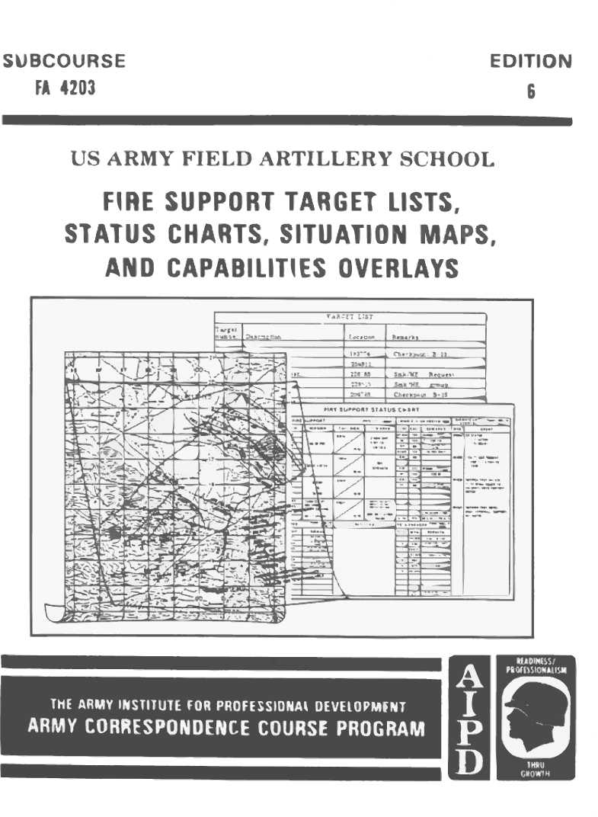

FIRE SUPPORT TARGET LISTS, STATUS CHARTS,SITUATION MAPS, AND CAPABILITIES OVERLAYS

SUBCOURSE FA 4203

US Army Field Artillery School
Fort Sill, Oklahoma

Eight Credit Hours

GENERAL

This subcourse is designed to train the skills necessary for performing tasks related to fire
support targets, status charts, situation maps, and capability overlays. This subcourse is
presented in five lessons, each lesson corresponding to a terminal objective supporting the
following soldier's manual tasks:

LESSON 1: Prepare/Submit Forward Observer Target List

TASK NO: 061-284-1001

TASK: Prepare/submit forward observer target list.

CONDITIONS: You will be given a map; a coordinate scale; a protractor; paper;
pencils; a CEOI, communication equipment; a digital message device
(DMD) (if equipped); and an information sheet containing a scheme
of maneuver/defense, a platoon leader's guidance, and a block of
target numbers.

STANDARDS: Submit a correct and complete forward observer (FO) target
list to the FIST.

LESSON 2: Maintain Information on a Status Chart

TASK NO: 061-284-1003

TASK: Maintain information on a status chart.

CONDITIONS: You will be given a fire support status chart, grease pencils, and an
information sheet containing pertinent fire support information.

STANDARDS: Correctly display all nongraphical information required by the FSO
indicating the current status of fire support assets responsive to the
supported unit commander.

i
_

LESSON 3: Post Information on a Fire Support Situation Map

TASK NO: 061-284-1011

TASK: Post information on a fire support situation map.

CONDITIONS: You will be given map sheets mounted and covered with acetate,
plotting equipment, grease pencils, and current tactical information.

STANDARDS : Correctly plot and label all current tactical information on a map.

LESSON 4: Consolidate/Process Forward Observer Target Lists

TASK NO: 061-284-3001

TASK: Consolidate/process forward observer target lists.

CONDITONS: You will be given a map; a coordinate scale; a protractor; a pencil;
paper; overlay paper; a CEOI; FM 6-20; communication equipment;
and an information sheet containing a scheme of maneuver/defense,
commander's guidance, and a forward observer target list.

STANDARDS: Produce a consolidated target list, and transmit/dispatch it to the
appropriate fire support agencies.

LESSON 5: Prepare a Fire Support Capabilities Overlay

TASK NO: 061-284-6003

TASK: Prepare a fire support capabilities overlay.

CONDITIONS: You will be given a situation map, overlay paper, plotting equipment
and the location and type of all fire support elements.

STANDARDS: Correctly prepare an overlay that portrays range capabilities of all given
fire support elements IAW FM 6-20.

ii

TABLE OF CONTENTS

Section Page

TITLE PAGE . . . . . . . . . . . . . . . . . . . . . . . . . . . . . . . . . . . . . . . . . . . . . . . . . . . . . . i

TABLE OF CONTENTS . . . . . . . . . . . . . . . . . . . . . . . . . . . . . . . . . . . . . . . . . . . . iii

ADMINISTRATIVE INSTRUCTIONS . . . . . . . . . . . . . . . . . . . . . . . . . . . . . . . . v

GRADING AND CERTIFICATION INSTRUCTIONS . . . . . . . . . . . . . . . . . . . vi

Lesson 1: Prepare/Submit Forward Observer Target List
Introduction . . . . . . . . . . . . . . . . . . . . . . . . . . . . . . . . . . . . . . . . . . . . . . . . . . . 1
Target Classification . . . . . . . . . . . . . . . . . . . . . . . . . . . . . . . . . . . . . . . . . . . . 1
Developing Targets . . . . . . . . . . . . . . . . . . . . . . . . . . . . . . . . . . . . . . . . . . . . . 2
Target Numbering System. . . . . . . . . . . . . . . . . . . . . . . . . . . . . . . . . . . . . . . . 4
Plotting Targets. . . . . . . . . . . . . . . . . . . . . . . . . . . . . . . . . . . . . . . . . . . . . . . . . 5
Preparing Target Lists . . . . . . . . . . . . . . . . . . . . . . . . . . . . . . . . . . . . . . . . . . . 6
Target List Approval. . . . . . . . . . . . . . . . . . . . . . . . . . . . . . . . . . . . . . . . . . . . . 7
Target List Submission. . . . . . . . . . . . . . . . . . . . . . . . . . . . . . . . . . . . . . . . . . . 7
Summary. . . . . . . . . . . . . . . . . . . . . . . . . . . . . . . . . . . . . . . . . . . . . . . . . . . . . . . 9
Lesson 2: Maintain Information on a Status Chart
Introduction . . . . . . . . . . . . . . . . . . . . . . . . . . . . . . . . . . . . . . . . . . . . . . . . . . . 11
Information and Description. . . . . . . . . . . . . . . . . . . . . . . . . . . . . . . . . . . . . . 11
Summary. . . . . . . . . . . . . . . . . . . . . . . . . . . . . . . . . . . . . . . . . . . . . . . . . . . . . . 13
Lesson 3: Post Information on a Fire Support Situation Map
Introduction. . . . . . . . . . . . . . . . . . . . . . . . . . . . . . . . . . . . . . . . . . . . . . . . . . . . 15
Fire Support Situation Map. . . . . . . . . . . . . . . . . . . . . . . . . . . . . . . . . . . . . . . 15
Military Symbols. . . . . . . . . . . . . . . . . . . . . . . . . . . . . . . . . . . . . . . . . . . . . . . . 15
Colors. . . . . . . . . . . . . . . . . . . . . . . . . . . . . . . . . . . . . . . . . . . . . . . . . . . . . . . . . 20
Unit and Installation Symbols. . . . . . . . . . . . . . . . . . . . . . . . . . . . . . . . . . . . . 21
Maneuver Control Measures. . . . . . . . . . . . . . . . . . . . . . . . . . . . . . . . . . . . . . 25

iii

Page
Fire Support Coordinating Measures. . . . . . . . . . . . . . . . . . . . . . . . . . . 29
Unit Locations . . . . . . . . . . . . . . . . . . . . . . . . . . . . . . . . . . . . . . . . . . . . . 33
Summary. . . . . . . . . . . . . . . . . . . . . . . . . . . . . . . . . . . . . . . . . . . . . . . . . . 37
Lesson 4: Consolidate/Process Forward Observer Target Lists
Introduction. . . . . . . . . . . . . . . . . . . . . . . . . . . . . . . . . . . . . . . . . . . . . . . . 39
Field Artillery Support Plan . . . . . . . . . . . . . . . . . . . . . . . . . . . . . . . . . . 39
Target List Processing . . . . . . . . . . . . . . . . . . . . . . . . . . . . . . . . . . . . . . . 39
Summary. . . . . . . . . . . . . . . . . . . . . . . . . . . . . . . . . . . . . . . . . . . . . . . . . . 54
Lesson 5: Prepare a Fire Support Capabilities Overlay
Introduction. . . . . . . . . . . . . . . . . . . . . . . . . . . . . . . . . . . . . . . . . . . . . . . . 55
Fire Support Capabilities Overlay. . . . . . . . . . . . . . . . . . . . . . . . . . . . . . 55
Preparing the Overlay. . . . . . . . . . . . . . . . . . . . . . . . . . . . . . . . . . . . . . . . 55
Summary. . . . . . . . . . . . . . . . . . . . . . . . . . . . . . . . . . . . . . . . . . . . . . . . . . . 61
EXAMINATION. . . . . . . . . . . . . . . . . . . . . . . . . . . . . . . . . . . . . . . . . . . . . . . . . . E-1

iv

ADMINISTRATIVE INSTRUCTIONS

Subcourse content. This subcourse contains five lessons, each related to one or more tasks in
preparation of target lists, posting information on status, charts, posting information on fire
support situation maps, processing forward observer target lists, and preparing a fire support
capability overlay. An introduction presents an overall view of the subject. Each lesson then
explains how to perform each task as it pertains to the fire support specialist.

_____________________________________________________________________________

*** IMPORTANT NOTICE ***

THE PASSING SCORE FOR ALL ACCP MATERIAL IS NOW 70%.

PLEASE DISREGARD ALL REFERENCES TO THE 75% REQUIREMENT.

_____________________________________________________________________________

Materials needed. - You will need:
a. Number 2 pencil, grease pencil, and paper (to be furnished by the student)
b. Plastic coordinate scale (at the end of this subcourse).
c. Overlay paper (at the end of this subcourse).
d. ZARKI map (at the end of this subcourse).
e. Prerequisites IS0788 and FA4025.
NOTE: If you do not have FA 4000-9, request the materials by writing or calling:
Army Correspondence Course Program
(ACCP) US Army Training Support Center
Newport News, VA 23628-0001
Telephone: (804) 878-2079, AUTOVON: 927-2079

Supervisory assistance. There are no supervisory requirements for completion of this
subcourse.

References. No supplementary references are needed for this subcourse.

v
GRADING AND CERTIFICATION INSTRUCTIONS

Instructions to the student. This subcourse has an examination that is a performance-based,
multiple-choice test covering five lessons. You must score a minimum of 75 percent on this
test to meet the objectives of the subcourse.

Credit hours. Eight credit hours will be awarded for successful completion of this subcourse.
_

vi

Lesson 1
PREPARE/SUBMIT FORWARD OBSERVER TARGET LIST

OBJECTIVE

After completing this lesson, you will be able to prepare and submit a forward observer target
list.

REFERENCES

This subcourse is based on FM 6-20, FM 101-5-1 (approved final draft, January 1985), and
other material approved for US Army field artillery instruction; however, development and
progress render the text continually subject to change. Therefore, base your examination
answers on material presented in this subcourse rather than on individual or unit experience.

1. INTRODUCTION. A battalion or brigade fire, support officer (FSO) must have a great
deal of fire support information immediately available. Detailed information concerning the
location, mission, and current status of fire support assets is essential for effective fire support.
Methods of information collection to be used will depend on the desires of the FSO and unit
standing operating procedure (SOP). Maps, overlays, and target lists normally are prepared and
maintained by the fire support specialist and used by the FSO to update firing and target data to
achieve maximum effective fire support.

2. TARGET CLASSIFICATION. A target may be materiel, personnel, or terrain that is
designated and numbered for reference and/or firing. Targets are classified as two types:

- Planned targets.
- Targets of opportunity.
a. Planned targets are those for which fire is prearranged. They are subdivided into on-call targets and scheduled targets.

(1) On-call targets are planned targets that will be attacked on request instead of at a
specified time.

(2) Scheduled targets are planned targets on which fire is to be delivered at a designated
time (for example, H-hour) or upon completion of a predetermined movement or
task. Prearranged fires are planned on:

- Confirmed enemy locations.
- Suspected enemy locations.
- Likely enemy locations.
- Prominent terrain features, and maneuver checkpoints.

1
b. Targets of opportunity usually are temporary in nature; have not been considered, analyzed, or planned previously; and should be attacked as soon as possible.

PRACTICE EXERCISES:

Complete the following exercises by circling T for true or F for false, circling the letter preceding the correct answer, or filling in the blanks as appropriate. Be sure to complete the practice exercises as they appear. They are "building blocks" and will help you complete the rest of the subcourse successfully. The answers follow the last exercise and are separated by rows of slashes (/ / / /) . If any of your answers are incorrect, restudy the appropriate part of the subcourse before you continue.

- Targets that are planned and fired on when requested are called
________________ ________________.

////////////////////////////////////////////////////////////////////////////////

ANSWER:

1. on-call targets.
_
////////////////////////////////////////////////////////////////////////////////////////

3. DEVELOPING TARGETS. The key to developing targets is to be aggressive. Seek out those people who can help you find targets. Here are a few sources:

- Platoon leader.
- Direct observation.
- Terrain analysis.
- Ground surveillance radar.
- Unattended ground sensors.

a. The maneuver company platoon leader is instrumental in determining the type of targets that you will develop. Everything you do is designed. to fit the platoon leader's scheme of defense or offense. When he briefs you, be sure that you understand every detail. Find out what he expects from his supporting artillery and how he plans to accomplish his mission. Use your briefing with the company FSO to obtain information for the platoon leader concerning available fires. Ask the platoon leader for any suspected or known enemy locations. Determine if there is any present fire planning requirements. Ask to be present when the platoon leader debriefs patrols. After the debriefing, ask the patrol members if they have observed anything that might indicate the presence of a target.

2

b. Be an expert at direct observation. Know your enemy and his equipment. For example, Warsaw Pact countries use a combined observation post/command post/fire direction center (OP/CP/FDC) in their artillery units. Not many personnel occupy such a position, but it requires more space than an OP. Knowing this, you can search your zone for likely OP /CP /FDC locations. If you attack an OP/CP/FDC, you can temporarily silence a howitzer battery. Look for disturbed areas (recent digging, bunkers, odd-color foliage, well-used paths, etc.), or anything that might tip off the enemy's location.

c. Terrain analysis is one of the forward observer's most valuable tools. Use your map to study areas that cannot be observed directly. Again, know your enemy. If the enemy likes to mass large forces quickly before an attack, search for wooded areas with numerous roads and trails that might be possible assembly areas. A properly timed attack on enemy massed forces might disrupt an imminent attack. Familiarize yourself with the size and type areas the enemy likes to use and search your map for them. Don't restrict your targeting to just your zone of observation. The enemy does not respect platoon boundaries, and the supported unit can be affected by activity outside the zone. Therefore, if an area appears a likely enemy target, plot it. If a problem exists with a target located outside your zone, the company FSO will resolve it.

d. Ground surveillance radars and unattended ground sensors are excellent sources of targeting information. If these items are assigned to the supported unit, talk to the personnel operating them. Reports of regular activity in the same locations are particularly useful. Considering your terrain analysis and direct target observation, you may be able to determine what the target is even if you cannot see it.

e. There are some special considerations in developing targets for both offense and defense. On offense, plan suppression fires and make sure that the supporting artillery knows what you want. A well-placed gun, tank, or automatic weapon can disrupt your supported unit's attack if not quickly suppressed. On defense, know exactly where the maneuver company platoon leader wants his final protective fires (FPFs) if they are assigned to him. Fire FPFs as soon as possible. If a withdrawal to other fighting positions is planned or likely, plan fires on your current position and on terrain features that will affect the withdrawal route. Whether on offense or defense, put yourself in your next location and plan several fires to be available immediately after you occupy it.

PRACTICE EXERCISE:

2. T F A thorough knowledge of the enemy is essential to target development.

////////////////////////////////////////////////////////////////////////////////

ANSWER:

2. T

///////////////////////////////////////////////////////////////////////////////////////

3

4. TARGET NUMBERING SYSTEM. A target number is an alphanumeric designator consisting of two letters and four numerals. The target numbering system provides for easy use within the unit, identification of the planning and designating source so that the target can be readily identified, and the capabilities of the current computer system. A sample use of the six-place (AB1448) numbering system follows:
_

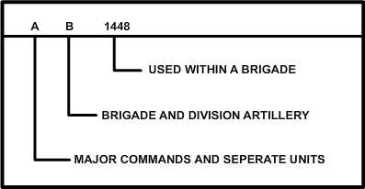

- The first letter (A) identifies the major command or separate unit within a corps.

- The second letter (B) identifies the major commands and selected fire planning elements assigned by division.

- The numerals 1448 identify major fire planning agencies within a brigade (brigade fire support element [FSE], maneuver battalion FSE, field artillery (FA) direct support battalion FDC, FISTs, etc.).

The FSO with the maneuver battalion assigns target numbers used by the FIST.

a. Use a priority system to assign target numbers. If you run out of target numbers, request more. Develop some method of determining target priority; too many on-call targets may cause confusion.

b. Your job is to help the platoon leader accomplish his mission; therefore, his targets must come first. If you feel that some of the targets you have developed might be more important than the ones he has given you, seek his advice. He may decide to delete some of his original targets in favor of yours. In any event, keep the targets recorded and attack them as targets of opportunity at the appropriate time. Also, report them to the company FSO so that he can forward the information to the maneuver battalion FSO.

PRACTICE EXERCISE:

3. T F Target numbers used by the FIST are assigned by the maneuver battalion FSO.

4

////////////////////////////////////////////////////////////////////////////////
ANSWER:
3. T

////////////////////////////////////////////////////////////////////////////////

5. PLOTTING TARGETS. Not all targets can be attacked by use of a normal battery sheaf. Size and shape will influence the type of sheaf to be used. Normally, the following target symbols will be used in plotting targets on the map:

a. The symbol for a conventional target is a cross and is used when a normal battery sheaf can effectively cover the target. It also may be used to mark the center grid of an irregularly shaped target. It may be canted if several targets are near each other or if the symbol could be confused with a grid line or intersection. The intersection of the lines represents the center of the target.

b. The linear target symbol is used for targets. that are long and narrow; for example, sections of roads and trench lines. The coordinates shown on the target list are for the center point. The target length and attitude also are shown.

c. The rectangular target symbol is used for targets that have both length and width. The coordinates shown on the target list are for the center point. The length and width shown on the target list represent the overall length and width of the target.

d. The circular target symbol is used for area targets. The coordinates shown on the target list are for the center point. The radius of the target also is shown on the target list.

e. The symbol for special targets (nuclear and chemical) closely resembles the symbol for a conventional target except that the lines are broken around the center of the symbol. The upper right quadrant contains the target number. The lower right quadrant contains the weapon type and yield. The lower left quadrant contains the delivery unit and time on target (TOT). The upper left quadrant contains the height of burst (HOB) or HOB option.
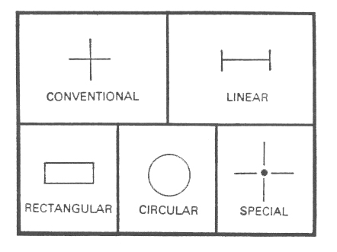

5

6. PREPARING TARGET LISTS. Once you have developed your targets and plotted them on the map, you can prepare the target list. The target list must contain at least the following three items for each target:

- Target number.
- Target description.
- Target location.
a. The target list is an informal document. The format shown in the following illustration will work well. Use a plain sheet of paper, and draw a format similar to the one shown.

TARGET LIST
...
TGT NO. | DESCRIPTION | GRID LOC. | REMARKS

b. For each target developed, enter the target number in the first column. On some occasions, the company FSO may not allocate target numbers to you but may prefer to wait until all target lists have been submitted. After he resolves any discrepancies in the target lists, he will consolidate the targets and prepare a consolidated target list.
c. Describe the nature of the target in enough detail that the FDC can determine the best method of attacking the target. This does not mean that if you have identified an OP, you should describe it as "OP with seven men, two' radios, and a telephone." Use common sense.

d. Enter the six-digit grid coordinates of the target. If eight-digit coordinates are available, use them. The more accurate the location, the more effective the fire will be.

6
e. Add any remarks that will help obtain the desired effect on the target (e.g., radius 150; 50% HE/VT; immediate suppression).

PRACTICE EXERCISE:

4. The three items required on a target list are _______________ ______________,
____________ ______________, and ___________ _____________ .

////////////////////////////////////////////////////////////////////////////////

ANSWER:
4. target number, target description, target location.

////////////////////////////////////////////////////////////////////////////////

7. TARGET LIST APPROVAL. Once your target list is complete, the maneuver
platoon leader must approve it. He will review the list and the target plots on the map. He may change the list. Remember that things do not always remain the same in the rapidly changing situation of combat and in the brief time it takes to develop a target. Once the platoon leader approves the target list, give him a copy. Make sure he knows about any targets for which you did not have numbers.

8. TARGET LIST SUBMISSION. After approval of the target list, send it to
company FSO. You can do this in any of three ways. In order of priority, these are--

- Hand-carry it.
- Send it by wire communication.
- Send it by FM radio.

a. Obviously, hand-carrying the list is preferred since there is less chance for compromise. However, because of time limitations or other factors, you may have to use an alternate method.

b. The next best way is to send it by wire communication.

c. If necessary, transmit the list by FM radio. Encode the list, or use secure equipment.

d. Once you have submitted the list, avoid unnecessary changes. Changes can cause confusion. If you have done your target planning effectively, you can use the targets already listed to shift fire onto new targets.

PRACTICE EXERCISE:

5. The best method of submitting a target list is to--

a. hand-carry it.
b. send it by wire communication.
c. send it by FM radio.

7

////////////////////////////////////////////////////////////////////////////////
ANSWER:
5. a.
////////////////////////////////////////////////////////////////////////////////

SELF-EVALUATION EXERCISE:

1. Six targets have been plotted on the following map extract. U sing a blank sheet of paper or DA Form 4655-R (Target List Work Sheet), prepare a forward observer target list. You have been assigned target numbers AB3001 through AB3006, and target descriptions are as follows:

TARGET DESCRIPTION
A 122-mm G/H position
B OP
C Trench line
D OP
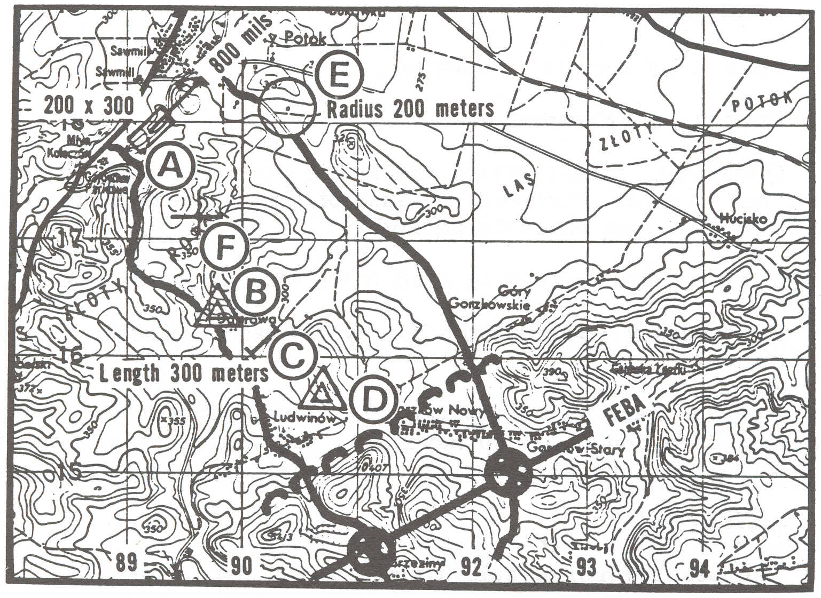 E Suspected assembly area Automatic weapon position

8

////////////////////////////////////////////////////////////////////////////////

ANSWERS:

1.

TGT NO. | DESCRIPTION | GRID LOC. | REMARKS
AB3001 | 122 G/H Btry | 892179 | 200 x 300 attitude 800
AB3002 | OP | 898166 | 50% VT
AB3003 | Trench line | 902161 | Length 300 attitude 800
AB3004 | OP | 907159 | 50% VT
AB3005 | Assembly area | 904181 | Radius 200
AB3006 | Automatic Wpn | 896172 | 50% VT

A

B

C

D

E

F

////////////////////////////////////////////////////////////////////////////////

9. SUMMARY. In preparing the forward observer target list, keep in mind that knowing the enemy and his requirements is most important to the unit FDC in selecting the proper fire mission. Study your map carefully, since terrain analysis is one of the forward observer's most valuable tools. Search for wooded areas that cannot be observed directly. Look for roads and trails possibly leading to assembly areas. If an area appears to be a likely target, plot it. Also, if your unit is supported by ground surveillance radars and sensor devices, they may be used in reporting activities that cannot be observed directly.

9

Lesson 2

MAINT AIN INFORMATION ON STATUS CHART

OBJECTIVE

After completing this lesson, you will be able to compile and maintain current information on a fire support status.

10. INTRODUCTION. The fire support planner regardless of the command level at which he works uses various aids to help him accomplish his mission. Relatively detailed information on the location, mission, and current status of available fire support assets is essential to efficient use of fire support. There are many methods of keeping track of this information, because there are many individuals who must know it. Fire support status charts, situation maps, overlays, notebooks, and scratch pads can be used for keeping track of information. The primary consideration of the FSO is to ensure that charts reflect the most current status of available fire support. However, any methods and size that are used should allow for ease in updating data. U sing charts covered with acetate and making annotations with a grease pencil are probably the most common methods of keeping data current.

11. INFORMATION AND DESCRIPTION.

a. Considerations. At the maneuver battalion and brigade, space limitations and an informal atmosphere normally permit the use of a single chart. A notepad may suffice for the company FSO. At higher echelons (above battalion and brigade) the same information, although in greater detail, may be found on several charts. The degree of detail and volume of information will conform to the desires of the commander, but the primary consideration of the FSO is to ensure that the charts reflect the most current status of available fire support means. The size of the chart greatly depends on the storage space available during tactical moves. For example, the FSO with an air assault infantry battalion may have a pocket-size chart. No specific form is prescribed for the fire support status chart, and each FSO must determine what information is vital. However, standardization within a particular command (DS battalion or division artillery) should be considered whenever possible. The following illustration shows a typical fire support status chart arranged with columnar blocks and spaces for what is considered to be necessary and desirable data about available fire support means.

11

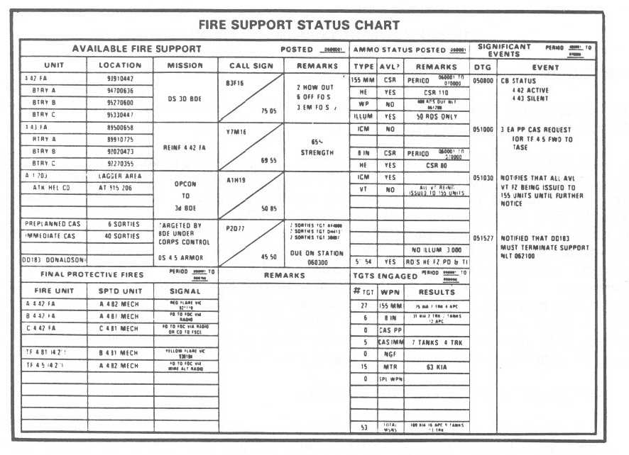

b. Scope and Quantity. The fire support status chart should display all non-graphical information required by the FSO to keep himself and others informed of the current status of all fire support assets responsive to the maneuver force commander (Lesson 3). These assets could include field artillery, attack helicopters, naval gunfire, close air support, and heavy (l07-mm) mortars. The scope and quantity of this information are regulated by two considerations:

- The principal consideration is a requirement to determine just what information is essential to coordinating activities and what information is merely nice to have. All charts can become monsters that consume vital time and effort in keeping nonessential information current.

- Once pertinent information has been identified, the FSO must realistically evaluate his ability, with the personnel and communications available, to obtain this information on a timely basis. He may find that some data can be updated as events occur; other information is obtainable only at 12-hour intervals.

c. Flexibility. The type of information required in chart form (non-graphic) is subject to radical changes on short notice. Recent developments in the tactical situation may add new significance to what was previously nice-to-know information. Changes in commanders or their attitudes often necessitate modification of the type of information displayed. These situations require that the FSO stay attuned to the desires of the supported commander and the needs of all members of the fire support teams and elements. The FSO should have the information he needs when he needs it with a minimum expenditure of time and effort.

12
PRACTICE EXERCISES:

6. The FSO's primary consideration for information maintained on his fire support status chart is to ensure that the chart reflects _________ _________ _________ _________of available fire support.

7. The FSO with an air assault infantry battalion may have a ________________-size chart.

8. Once pertinent information has been identified, the FSO must realistically evaluate his ability to obtain this information on ____________ ____________ ____________.

9. Roughly categorized, the information habitually required and maintained by the FSO includes that information regarding--
a. ____________________________________________________________________________.
b. ____________________________________________________________________________.
c. ____________________________________________________________________________.
d. ____________________________________________________________________________.
e. ____________________________________________________________________________.

////////////////////////////////////////////////////////////////////////////////

ANSWERS:

6. the most current status
7. pocket
8. a timely basis.
9. a. the supporting FA units.
b. ammunition.
c. FPF allocation.
d. targets attacked.
e. coordinating/restricting measures.

////////////////////////////////////////////////////////////////////////////////

12. SUMMARY. Graphic aids and charts are tools to help the fire support planner in-performing his duties more efficiently. When additions to or modification of aids discussed in this lesson will tend to increase efficiency, they should be made. The range of possibilities is limited only by the fire planner's imagination. The target overlay, together with the fire support capabilities overlay, aids in resolving duplications of planned targets, supplements the target list work sheets and the fire support status chart, helps to evaluate the adequacy of planned support in relation to the scheme of maneuver or plan of defense, and determines the most appropriate unit or units to attack a given target.

13

Lesson 3
POST INFORMATION ON A FIRE SUPPORT SITUATION MAP
OJECTIVE
After completing this lesson, you will be able to post information on a fire support situation map.

13. INTRODUCTION. Posting information Ion a situation map is vital to the successful operation of the supported unit. Keep in mind that symbols may become cluttered and lose their value if posted with unnecessary details. Locations of mortars and subordinate elements should be kept up to date. The size of your map will depend on the area of operation of the supported unit. Therefore, you may be forced to prepare an overlay for additional information.

14. FIRE SUPPORT SITUATION MAP. The fire support coordinator must have a great deal of information readily available. The fire support situation map provides much of this information including:

- Boundaries, phase lines, coordinating points, and other maneuver control measures.
- Locations of supporting field artillery units.
- Coordinating measures.
- Locations of subordinate elements of the supported maneuver unit.

The map normally is mounted on plywood and covered with acetate. Fire support information is drawn on the acetate by using standard military symbols found in FM 101-5-1. The size of the map will depend on the area of operation of the supported unit. If supporting field artillery and mortar locations tend to clutter the map, a separate overlay may be prepared to display this information as needed. The situation map may be set up in any manner that will furnish fire support personnel reliable information.

PRACTICE EXERCISE:

10. The size of the situation map depends on ________ _______ _________ __________
___________ __________ ___________ ___________.

////////////////////////////////////////////////////////////////////////////////

ANSWER:

10. the area of operation of the supported unit.

////////////////////////////////////////////////////////////////////////////////

15. MILITARY SYMBOLS. Military symbols are used to graphically identify items of operational interest. They can lose their value if they become complicated or cluttered with unnecessary detail. A flexible system is presented in this lesson to adapt the symbols to fit your own particular requirements.

15


a. The most basic symbol is the unit symbol:

b. Following are the symbols used to identify different types of units:

- Armor Task Force
Units forming a task force are

shown under one command by the
- Cavalry or Reconnaissance use of a bracket. This one is an
armored battalion task force formed
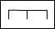
by two tank companies, one
- Engineer mechanized infantry company, one
armored engineer platoon, and one

aviation section.
- Field Artillery


- Infantry


- Mechanized Infantry

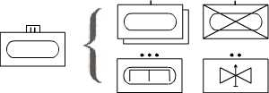
- Task Force

c. An appropriate marking, such as a dot ( ), a line ( ) ,or an X, is placed above the unit symbol to indicate the size (squad, company, brigade, etc.) of the unit.

- Squad

- Section or Unit

- Platoon or Detachment

- Company, Battery, or Troop

- Battalion or Squadron

- Group or Regiment

- Brigade X
16
- Division X X

- Corps X X X

- Army X X X X
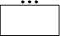
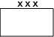
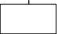
EXAMPLES:

(a platoon) (a company) (a corps)

REMEMBER:
- The starting point is the basic symbol:

- Add the branch inside the basic symbol:

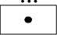
- Add the size:

d. Symbols are also used to indicate the type and location of a weapon or group of weapons. When a weapon symbol appears on a map or overlay, the base of the shaft indicates the location of the weapon. To show the approximate size of a particular weapon, the procedures are as follows:

(1) Select the appropriate weapon symbol.


EXAMPLES:

(basic infantry weapon) (basic artillery weapon)

(2) Add one horizontal bar (for medium) or two horizontal bars (for heavy) to denote approximate size. If no horizontal bar is shown, the light category is represented.

EXAMPLES:

(medium artillery gun) (light automatic weapon)

(3) If a weapon has a high trajectory, place at the base of the shaft.

17

EXAMPLE :

(medium mortar)
(4) If the weapon has a flat trajectory (antitank weapon) place a at the base of the shaft.


EXAMPLE:

(light antitank gun)

(5) If the weapon is primarily for air defense, place a at the base of the shaft.


EXAMPLE:

(heavy air defense gun)
(6) If the weapon is a rocket projector or launcher, place a _ at the head of the shaft.

EXAMPLE:


(light artillery rocket launcher)

(7) If a weapon is also a tracked self-propelled (SP) vehicle, place a a below the weapon symbol.


EXAMPLE:

(tracked self-propelled medium howitzer)

18
c. The following symbols are for light, medium, and heavy weapons.

LIGHT MEDIUM HEAVY



Machine Gun


Mortar


Antitank Rocket
Launcher


Antitank Missile,
Self - Propelled

Tank

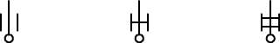
Howitzer

19

d. Another method of indicating weapon size is to write the caliber of the weapon to the right of the symbol.

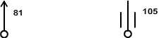
EXAMPLES:

(81-mm mortar) (105-mm howitzer)

PRACTICE EXERCISES:

11. From the units listed on the left, select the appropriate unit corresponding to each symbol and enter the unit in the space provided below the symbol.

Unit
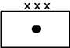

Squad
Section
Field Artillery Battery a. b.
Corps Artillery
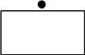
Infantry Battalion



c. d. e.

////////////////////////////////////////////////////////////////////////////////

ANSWERS:
11. a. Corps Artillery
b. Section
c. Infantry Battalion
d. Squad
e. Field Artillery Battery

///////////////////////////////////////////////////////////////////////////////

16. COLORS. The colors used on the situation map and overlays are not the same as the basic map colors that show built-up areas, rivers, or roads. Map colors and symbol colors are two different things. Caution must be exercised in using yellow and green, since these colors represent both friendly and enemy forces. If pencils of the colors needed are not available, make a legend and attach it to the front of the map for those personnel who will use the map or overlay. If colored pencils are not available, draw friendly symbols with single lines and enemy symbols with double lines.

20



EXAMPLES:

(enemy infantry division) (enemy observation post)

Color codes are as follows:

- Black or blue represents friendly units, installations, equipment, and activities.

- Red represents enemy units, installations, equipment, and activities.

- Yellow represents friendly or enemy areas of chemical, biological, or radiological contamination.

- Green represents friendly or enemy man-made obstacles.

PRACTICE EXERCISES:

12. The symbol color that represents friendly elements, installations, or their activities is ______
or _____________.

13. The symbol colors that represent both friendly and enemy man-made obstacles or contaminated areas are _____________ and ________________ .

////////////////////////////////////////////////////////////////////////////////

ANSWERS:

12. black, blue
13. green, yellow

////////////////////////////////////////////////////////////////////////////////

17. UNIT AND INSTALLATION SYMBOLS. Basic unit and installation symbols are drawn with either solid or broken lines. A solid line symbol represents the present. or actual location; a broken line symbol represents a future or projected location.


EXAMPLES:

(actual location) (projected location)

- The center of mass of the symbol indicates the general vicinity of the center of mass of
the unit represented. If a staff is added to identify a headquarters, the base of the staff indicates the exact location of the headquarters. To indicate locations more accurately, basic symbols other than the headquarters symbol may be placed on a central staff, which is extended or bent as required. The end of the staff indicates the exact location of the unit.
21

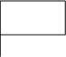
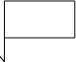
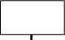
EXAMPLES:

OR

(a headquarters) (basic unit symbol)

b. If several headquarters are at one location, more than one symbol may be placed on a single staff.

EXAMPLE:

c. If a group of units or installations other than a headquarters is at one location, the grouping of symbols may be enclosed with a bracket and the exact location indicated with a staff.

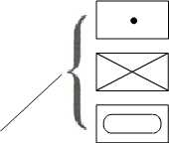
EXAMPLE:

PRACTICE EXERCISES:

14. a. Draw the symbol for a projected unit location.

b. Draw the symbol for a headquarters location.

////////////////////////////////////////////////////////////////////////////////
ANSWERS:
14. a. b. OR

////////////////////////////////////////////////////////////////////////////////

22

18. MANEUVER CONTROL MEASURES. The following symbols are primarily used to control tactical maneuvers:

a. Assembly areas are areas in which the command is assembled to prepare for operations. The areas are enclosed, and the unit symbol is placed in the center. Proposed areas are shown with broken lines.



b. If an area is occupied and defense of the area is prepared, a line including the size symbol of the defending unit encloses the battle position. The side of the battle position that is farthest from the enemy will contain the size symbol for the unit enclosed.




c. A boundary is a control measure used to delineate an area of tactical responsibility for subordinate units. It is marked by a solid black line with the unit size indication of the unit shown at convenient intervals. The size symbol of the larger unit is used on the lateral boundaries.

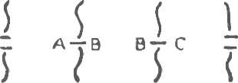

23

(1) If a rear boundary is shown, the size indication of the smaller unit is used on the boundary.

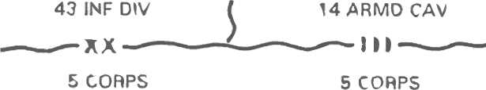

(2) Future or proposed boundaries are shown with broken lines and are labeled to indicate date and time or condition when effective (eff) and the headquarters establishing the boundary.

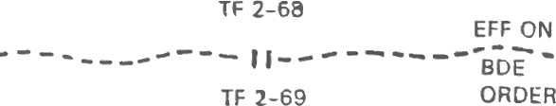

d. A checkpoint is a point on the ground designated to provide a reference for rapidly reporting specific locations and information about the control of units. The checkpoint symbol is a square with a triangle on the bottom enclosing a selected terrain feature with a number, letter, or code name placed inside the square. (The exact location is the tip at the bottom of the symbol.)

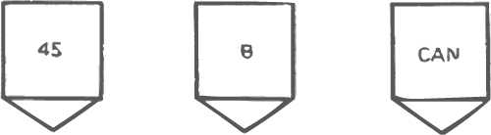

e. A contact point is a designated, easily identifiable point on the terrain where two or more units are required to make physical contact. The contact point is a square with the contact number inside.



f. Coordinating points are specific points for the coordination of fires and maneuver between adjacent units in defense. They are shown by drawing a circle on the selected terrain features and placing an X in the center. (The exact location is the center of the symbol.)



24
EXAMPLES:


(forward edge of the (trace of the forward edge
battle area) of the battle area)

g. Linkup points show where forces linking up are to make contact. The points are shown as a square with a triangle on the bottom with a dot and a number in the center of the square.


h. A line of contact (LC) is a line where the forward friendly positions are in contact with the opposing forces. The line is shown as a line of solid half circles with the letters LC at each end.

i. A line of departure (LD) is a line designated to coordinate the departure of attack or scouting elements. The line of departure is shown as a solid line with the letters LD at each end.

j. The direction of attack is a specific direction or route that the main attack or the main body of the force will follow. The direction of attack is shown graphically as an arrow extending from the line of departure to the objective (obj). The arrow normally is not labeled.

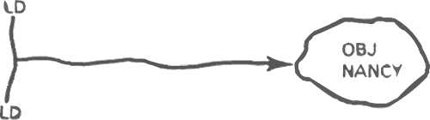

25
k. The forward edge of the battle area (FEBA) designates the area where the main defensive effort is to begin. The FEBA should be designated on terrain favorable to the defender. The FEBA is shown as a series of coordinating points on unit boundaries. The acronym FEBA is placed on either side of the parent unit boundaries and coordinating points.
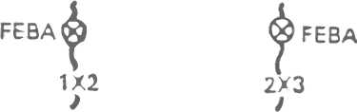

1. An axis of advance is a line of advance assigned for the purpose of control, often a road or group of roads or a designated series of locations extending in the direction of the enemy. The axis of advance is shown as an open arrow extending only as far as this form of control is essential to the overall plan. The axis of advance is labeled with a code name or unit designation.

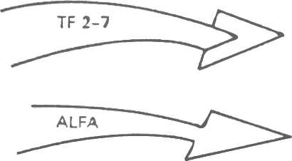
Double arrowhead for direction of
main attack and axis of advance
for the main attack.

Single arrowhead for supporting
direction of attack and supporting
axis of advance.

m. Objectives are enclosed and identified by the abbreviation OBJ and a number, letter, code name, or unit designation.

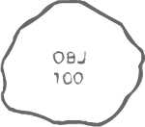


n. An observation post (OP) is shown as a triangle, and the top of the triangle designates the location on the ground.


o. A passage point is a point where units will pass through one another in either the advance or withdrawal. The passage point is shown by a square with a triangle at the bottom and the letters PP and a number designation within the square.
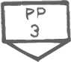

26

p. A point of departure (PD) is used in operations during periods of limited visibility. The point of departure is the exact point where attacking platoons physically cross the line of departure. The point is shown as a box with a triangle at the bottom and the letters PD and a number inside.

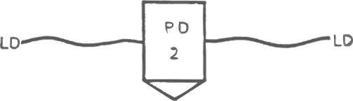

q. A pickup zone (PZ) is a designated area for pickup or loading of troops or equipment by helicopter.

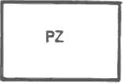


OR

r. A drop zone (DZ) is a designated area where airborne troops or equipment are air-dropped.


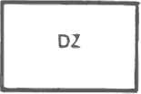

OR

s. A start point (SP) is a well-defined point on a route at which movement of vehicles comes under the control of the commander having responsibility for the movement. The start point is shown as a square with a triangle on the bottom with the designation SP centered in the square.


t. A release point (RP) is a well-defined point on a route at which elements composing a column revert to the control of their respective commanders. A release point is shown as a square with a triangle on the bottom with the designation RP centered in the square.


27

u. A phase line (PL) is used for control and coordination of military operations. Phase lines provide linear reference on the battlefield. A phase line should be extended across the entire zone or sector of action. A phase line is a solid black line labeled on each end with the abbreviation PL and an assigned code name, letter, or number for identification.
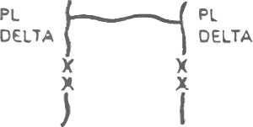

v. A strongpoint (SP) is a specific location, normally designated by a brigade or higher level commander. Strongpoints are designated to cause the enemy to mass in front of them, thereby generating a high density of targets that are susceptible to destruction. A strongpoint is shown as an enclosed area with the letters SP and an identifying number inside. A strongpoint may also be shown as a partially enclosed area with the unit size symbol opposite the direction of defense.



w. A fortified area is shown as a closed area with a series of half circles around the inside of the area.



x. A trench system is shown as a series of open-ended squares joined together (fortified line). If the trench has firing bays, they are shown by putting straight lines on the enemy side of the trench symbol.

OR

y. A gap is a portion of a barrier or obstacle system in which no obstacles have been constructed. It is wide enough to enable a friendly force to pass through in tactical formation. It is seldom less than 100 meters wide. The gap is shown with double lines that are drawn to represent the approximate
width of the actual gap on the ground.
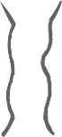
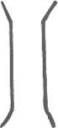

OR

28

z. A lane is similar to a gap except it is intended to accommodate lines of personnel and is 1 meter wide and may be further expanded; vehicle lanes are 8 to 15 meters wide. They are shown as single lines.


OR

PRACTICE EXERCISES:

15. a. Draw the symbol for a line of contact.

b. Draw the symbol for a line of departure.

c. Draw the symbol for a coordinating point.

////////////////////////////////////////////////////////////////////////////////
ANSWERS:
15. a.

b.

c.

////////////////////////////////////////////////////////////////////////////////

19. FIRE SUPPORT COORDINATING MEASURES. Fire support coordinating measures are divided into two groups: permissive and restrictive.

a. Permissive measures permit the engagement of targets beyond a line or into an area without further coordination. The permissive measures are drawn in black on overlays and maps. The permissive fire support coordinating measures that will be discussed are the coordinated fire line (CFL), the fire support coordination line (FSCL), and the free-fire area (FFA).

29

(1) The coordinated fire line (denoted by a broken black line) is a line beyond which any conventional surface fire support means may fire within the zone of the establishing headquarters without additional coordination. The letters CFL and the establishing headquarters are written above the line, and the effective date-time group is written below the line.

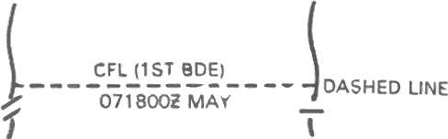

(2) The fire support coordination line is a line beyond which all targets may be attacked by any weapon system (including aircraft and special weapons) without endangering friendly troops or requiring additional coordination with the establishing headquarters. The FSCL is located on terrain that is easily identifiable from the air, such as a road or river. The letters FSCL and the establishing headquarters are above the line, and the effective date-time group is below the line.

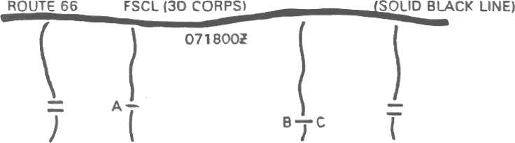

(3) The free-fire area is a specific area into which any weapon system may fire without additional coordination with the establishing headquarters. The FFA should be located on identifiable terrain, but it can also be located by grid coordinates. The letters FFA, the establishing headquarters, and the date-time group that it is effective are all shown inside the FFA. The FFA is used to expedite fires and facilitate the jettison of munitions when aircraft are unable to drop them on a target area.

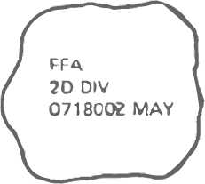
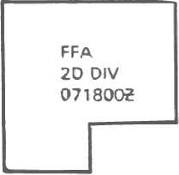

OR

b. To see how permissive measures appear on a situation map, look at the following illustration. Remember, all permissive measures are drawn in black. Also included are some boundaries and coordinating points.

30

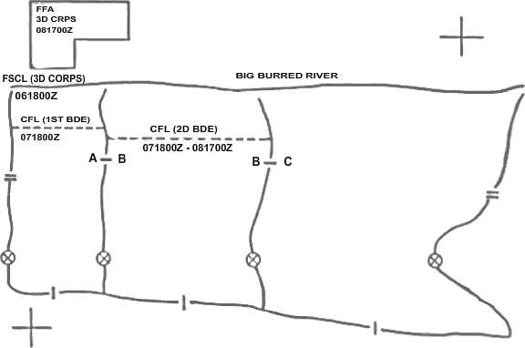

c. Restrictive measures mean that fires, or the effects of fires, into an area or across a line must be coordinated with the establishing headquarters of the affected force on a mission-by-mission basis. Restrictive measures are drawn in red. Restrictive measures are the restrictive fire line (RFL), the restrictive fire area (RFA), the no-fire are (NFA), and the airspace coordination area (ACA).

(1) A restrictive fire line is a line established between converging friendly forces by the commander common to the converging forces. The RFL prohibits fires or the effects of fires across the line without coordination with the affected force. The RFL is located on identifiable terrain, usually closer to the stationary force. The letters RFL and the establishing headquarters are shown above the line, and the date-time group is below the line. The purpose of the RFL is to prevent interference between converging friendly forces.

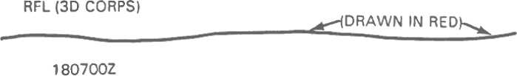

(2) A restrictive fire area is an area in which specific restrictions are imposed. The RF A is located on identifiable terrain to facilitate recognition from the air. It may also be identified by a grid or by a radius from a center point. The letters RF A, the establishing headquarters, and the effective date-time group are shown inside the area. The purpose of the RF A is to regulate fires into an. area according to the stated restrictions.

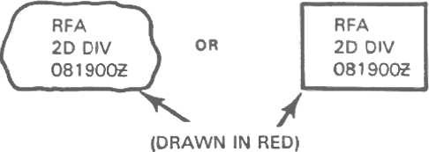

31
(3) A no-fire area is an area into which no fires or effects of fires are allowed. Two exceptions are- -

- When establishing headquarters approves fires on a mission-by-mission basis.

- When an enemy force within the NFA engages a friendly force.

The NFA should be located on identifiable terrain; however, it may be located by grid designation or a radius from a center point. The letters NFA, the establishing headquarters, and the date-time group are all shown inside the area. The purpose of NFA is to prohibit fires or their effects in the area.

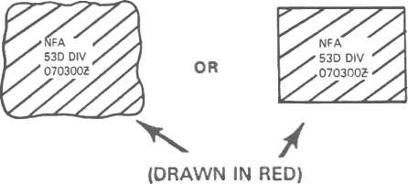

(4) An airspace coordination area is a block of airspace in the target area in which friendly aircraft are reasonably safe from friendly surface fires. The location of the ACA is graphically shown on situation maps and overlays as a rectangular area. You must include minimum and maximum altitudes, the effective date-time group, and the establishing headquarters. The lateral and depth limits are established by grid coordinates. The purpose of the ACA is to allow the simultaneous attack of targets near each other by multiple fire support means, one of which normally is air.

d. This covers all the fire support coordinating measures you will need to know at this time. The coordinating measures designate portions of the battlefield where actions mayor may not be taken. The fire support coordinator recommends them, and the commander establishes them. The coordinating measures facilitate operations by establishing rules and guidelines for selected areas for a given period of time.

32
PRACTICE EXERCISES:

16. a. All restrictive measures are drawn in the color __________ on maps and overlays.

b. The coordinated fire line is shown on the map as a-

(1) solid black line.

(2) solid red line.

(3) dashed black line.

(4) dashed red line.

////////////////////////////////////////////////////////////////////////////////
ANSWERS:

16. a. red
b. (3)

////////////////////////////////////////////////////////////////////////////////

20. UNIT LOCATIONS. Along with coordinating and control measures, you must also plot the locations of supporting field artillery units and subordinate elements of the supported maneuver units. Friendly unit locations must be plotted to the greatest possible accuracy to prevent endangering them with friendly fires. Symbols for supporting and supported units must be drawn by using standard military symbols. If symbols or color codes deviate from the standard format, construct a legend and attach it to the map. As artillery and maneuver unit locations change, you must also change the situation map to reflect the new locations. The map must be kept up to date at all times. If any information is classified, the highest security classification will be placed at both the top and bottom (centered) of the map.

SELF-EVALUATION EXERCISE:

2. On page 36 you will find a map extract. Remove the extract at this time and use it to prepare a situation map from the information given below:

TACTICAL SITUATION: You are in support of the 3d Brigade, 12th Mechanized Infantry, 10th Corps. Your eastern brigade boundary runs along the road from grid 015207 to 027153. The brigade western boundary runs along the road from grid 966182 to 955112. The 1st Brigade is on the east and the 2d Brigade is on the west.

A 3d Brigade coordinated fire line was established effective 101000 from grid 960160 to 020180.

33
A 10th Corps fire support coordination line (FSCL) was established effective 091600 from grid 962176 to 019195.

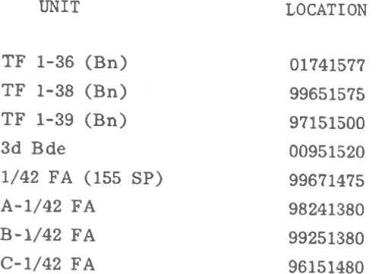

34
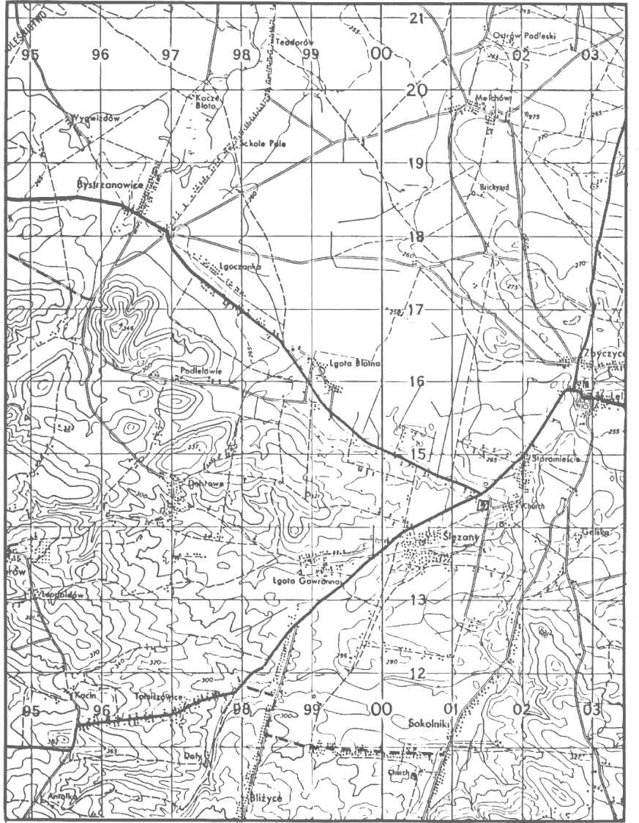

35

////////////////////////////////////////////////////////////////////////////////
ANSWER:
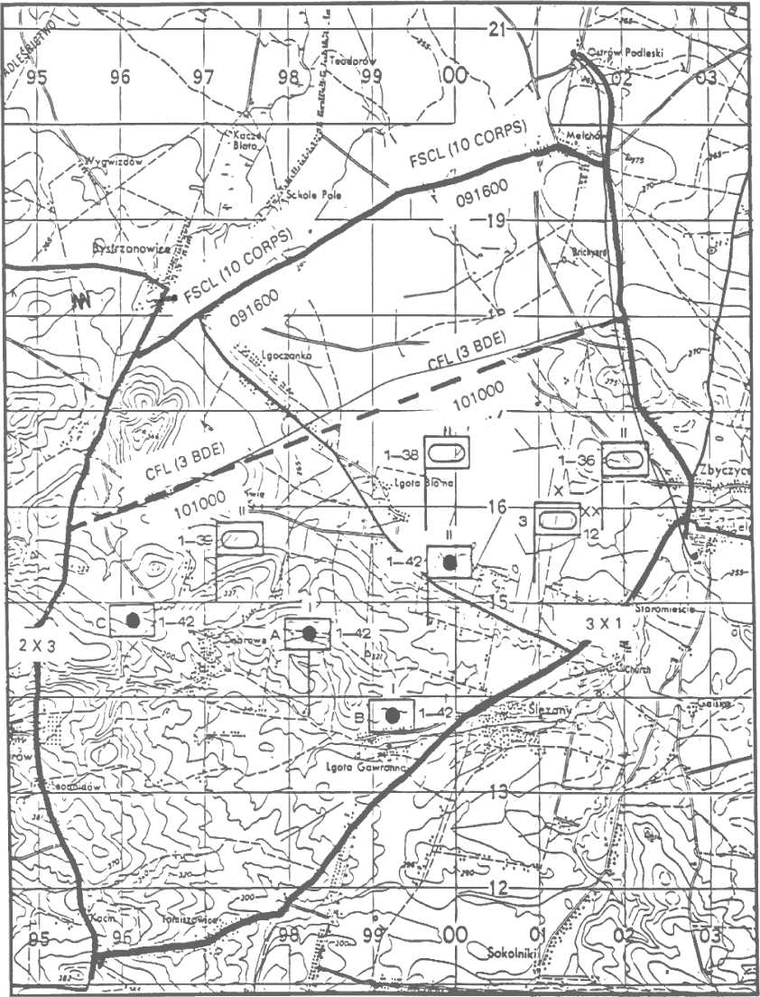

////////////////////////////////////////////////////////////////////////////////
36
21. SUMMARY. When posting information on a fire support situation map, keep in mind that the tactical situation is constantly changing. Colors used on situation maps are not the same colors as basic map colors. Caution must be exercised in using yellow and green, since they represent both friendly and enemy forces. Pay particular attention to unit symbols representing actual or projected future locations. Friendly units must be plotted to the greatest possible accuracy to prevent their being fired upon by friendly forces. Finally, if any classified information is posted, the security classification must be placed at both the top and the bottom (center) of the map.

37
Lesson 4
CONSOLIDATE/PROCESS FORWARD OBSERVER TARGET LIST

OBJECTIVE

After completing this lesson, you will be able to compile a target list, process a FIST target list, and consolidate a target list in accordance with accepted procedures.

22. INTRODUCTION. The company FSO normally will develop the observer targets and record them on his map. He must brief the FIST commander on his plan for FA support. The target description must be clear and concise for the fire direction officer to make a sound decision regarding the amount and type of artillery to be used on this target. The company FSO also must forward the target list to the maneuver battalion FSO by the most secure means available.

23. FIELD ARTILLERY SUPPORT PLAN. The FA support plan is the force artillery commander's tactical plan for using the fires of all available supporting field artillery. The FA operations officer (S3) prepares the FA support plan. It is based on command guidance, targets, and instructions in the fire support plan of the operation order (OPORD) or on verbal information from the FSE. The FA support plan optimizes the use of limited FA assets' available to support maneuver operations. It further disseminates the FA commander's guidance on how to accomplish the FA portion of the fire support plan. This guidance may include designation of specific units to attack critical targets that are a threat to the accomplishment of the mission, and the manner in which the supporting field artillery will engage the targets The written FA support plan may follow the oral presentation of those key elements needed by the units for timely execution. When completed, the FA support plan will contain a written portion, a target list, and the fire support schedules. The amount of detail used in fire support planning is dictated by the time available to prepare the plan. Contingency plans are updated periodically. However, the dynamics of the battlefield require that units act on the basis of SOPs and fragmentary (frag) orders rather than on lengthy written operation orders. Frag orders and OPORDs are issued to change or expand SOPs.

24. TARGET LIST PROCESSING.

- FIST targets. The FIST develops targets and assigns target numbers on the basis of the
company/team commander's guidance, the terrain, and the tactical situation. Maneuver checkpoints will be included in the target list and assigned target numbers that match, if possible, the checkpoint number. These targets are coordinated with other fire planners at company/team level (e. g., lO7-mm mortar platoon leader). The sources of these targets may include information obtained from--

- Direct observation.

- Combat patrols.

- Maneuver unit ground surveillance radars.

39

- Unattended ground sensors.

- The maneuver commander and staff.

- The maneuver battalion FSO.

- The DS battalion S2.

Normally, the company FSO will initially record these targets directly on his map
by using the prescribed target symbols (described in FA Subcourse 8157-9). He briefs the company/team commander on his plan for field artillery support of the company/team operations and obtains the commander's approval. Misunderstandings are avoided and accuracy is promoted when a well-prepared plan can be explained graphically as plotted on the FIST map below.

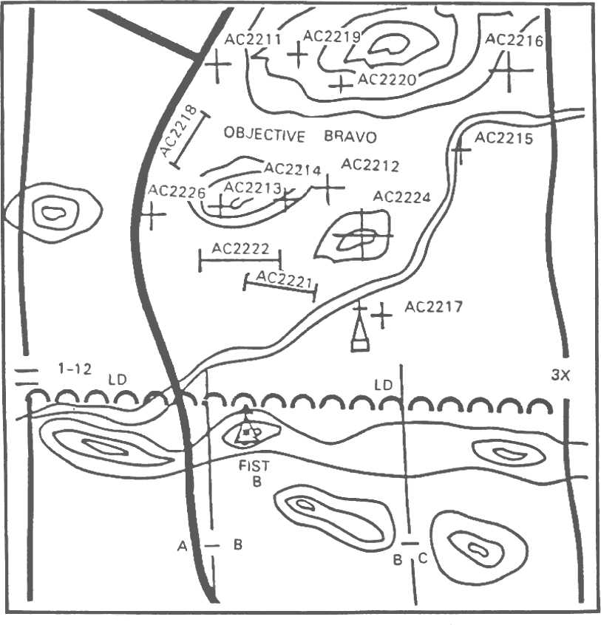

40
b. The FIST target list. The company FSO transfers the approved targets to a target list. The target list may have been constructed before the company/team commander's briefing but is subject to change as a result of his comments. The FIST target list is an informal document that contains all information required by the receiving FDC to identify, process, and compute technical firing data for the indicated targets. The target list is the only fire planning document prepared by the company FSO in support of a maneuver company/team operation. Normally, the company FSO's target list will include the following:

- The target number assigned by the FIST or the individual/agency that first designated the personnel/materiel/terrain as a target. Once a target number has been assigned to a target, the target will retain that target number until the target is of no further tactical value, at which time the target will be deleted from the target lists at all echelons.

- The description, or nature, of the target. The description must be accurate, clear, and concise so that the fire direction officer (S3/FDO) can decide on the type and amount of field artillery that will be used to attack the target. Checkpoints, objectives, and other sensitive areas should be described by the terrain feature on which they are located for operations security (OPSEC) reasons.

- The grid location of the target to an accuracy of at least six-place coordinates (100 meters). The more accurately a target is located, the more effective the first rounds on that target will be.

- Additional pertinent information about each target that would aid the FDO in determining the method of attack. Often the FIST / forward observer (FO) party submitting the target knows more about the specific nature of the target and the terrain surrounding it than anyone else on the battlefield. They may provide recommendations, special requests, target attitude (linear targets), or any other information that would affect the engagement of a target or targets. A number of targets near each other in an objective area normally would be requested as a group of targets.

The graphic on the following page shows the typical entries of a company FSO's target list.

41

TARGET LIST
TARGET  NUMBER | DESCRIPTION | LOCATION | REMARKS
AC2211 | Road junction | 193774 | Checkpoint B-11
AC2212 | Suspect mortar | 254811
AC2213 | Observation post | 226785 | Smk/HE request group
AC2214 | Observation post | 239813 | Smk/HE request group
AC2215 | Bridge | 204749 | Checkpoint B-15
AC2216 | Suspect FA battery | 226785
AC2217 | Church | 213767 | RP
AC2218 | Trench line | 211769 | 100 x 400 m—Attitude  1,600
AC2219 | Antitank weapon with overhead cover | 213778 | Fz delay--priority
AC2220 | Infantry dug- in | 209776
AC2221 | Trench line with A W | 230775 | Request group 200 m--ATT 2,150
AC2222 | Trench line | 225780 | Request group 300 m -- ATT 2,830
AC2223 | Wire entanglement | 222781
AC2224 | Hilltop/CP 24 | 234788 | Priority
AC2225 | Hilltop | 234781
AC2226 | Road bend | 221785 | Priority

Explanatory remarks:
1. Request targets AC22lB, AC22l9, and AC2220 as a series (timing specified by requester).
2. Request targets AC2221 and AC2222 (group) and AC2223 as a series (timing specified by requester).

c. Submission. The company FSO forwards the target list to the maneuver battalion FSO by the most secure means available within existing time constraints. If the situation permits, the company FSO or a member of his team should personally hand-carry the target list to the maneuver battalion FSO.

42
If wire communication has been established, the company FSO should establish a conference call with the FSO, the direct support battalion FDC, and the firing battery that has been supporting him and transmit his target list to all at the same time. If time precludes either of the above methods, the company FSO must encode his target list and transmit it to the FSO over the designated net. Results of friendly fires are normally transmitted in the clear. The direct support battalion and firing batteries will monitor and decode the transmission, plot the targets, and prepare appropriate technical data.

PRACTICE EXERCISES:

17 T F The FIST target list includes maneuver checkpoints.

18 T F Direct observation and combat patrols are some of the FIST target resources.

19 T F The FIST targets are initially recorded directly on the FIST target list.

20 T F The target list is finalized before the company commander's briefing.

21 T F The FIST target list contains all information necessary to identify, process, and compute
firing data for indicated targets.

22 T F The FIST target list is submitted to the DS battalion FDC by the most secure means available.

////////////////////////////////////////////////////////////////////////////////

ANSWERS:
17. T

18. T

19. F

20. F

21. T

22. F

////////////////////////////////////////////////////////////////////////////////

d. Battalion FSO. To ensure complete integration of all fire support systems into a coordinated fire support plan, the maneuver battalion FSO becomes involved in all aspects of fire support planning and coordination. The FSO-

- Receives target lists from the FIST of each maneuver company/team.

43

- Consolidates lists with other targets planned at the maneuver battalion.

- Places the targets on his consolidated target overlay, the graphical aid for resolution of target duplications.

- Compares targets with previously planned targets.

- Resolves duplications by deleting obviously similar requests on the same area.

- Assigns appropriate targets to the battalion mortar platoon.

- Forwards the processed and consolidated target list to the direct support battalion FDC.

The FSO does not wait until all FIST targets are submitted to him; rather, he processes each target or block of targets as it is received. Finally, the FSO forwards two copies of the consolidated list of planned targets. One copy of the consolidated list goes to the DS field artillery battalion FDC for technical processing and inclusion in the field artillery support plan. The other copy is sent directly to the brigade FSE for information and necessary coordination.

PRACTICE EXERCISE:

SITUATION:

23. TF 6-32 Armor prepares to attack Objective GOLD with Team A/6-32 Armor and Team C/l-8 Inf (Mech) on line. 1-19 FA (155, SP) is in direct support (DS) of 1st Bde. Company FSOs with Teams A and C have prepared their target lists for FA fires in support of the movement to contact. The FSO, TF 6-32 Armor, receives the following target lists:

a. From Team A company FSO:

TGT NO. | DESCRIPTION | LOCATION | REMARKS
BA2021 | Strong point | 64486675 | On-call
BA2022 | Machine gun | 62606586 | 50% smk
BA2023 | Antitank weapon | 63656355 | Priority

44

b. From Team C company FSO:

TGT NO. | DESCRIPTION | LOCATION | REMARKS
BA2274 | Squad strong point | 60186746 | On-call
BA2275 | Observation point | 61306605 | 50% VT
BA2276 | Antitank weapon | 59606458 | Priority
BA2277 | Automatic weapons | 62556590 | 50% smk

45
REQUIRED:

You are the FSO for TF 6-32 Armor. Process the target lists.

a. Plot the targets on your situation map (partial map below).

b. Resolve duplications and inform the company FSOs of your action.

c. Prepare a consolidated target list (use the spaces in the consolidated target list [next page] as needed).

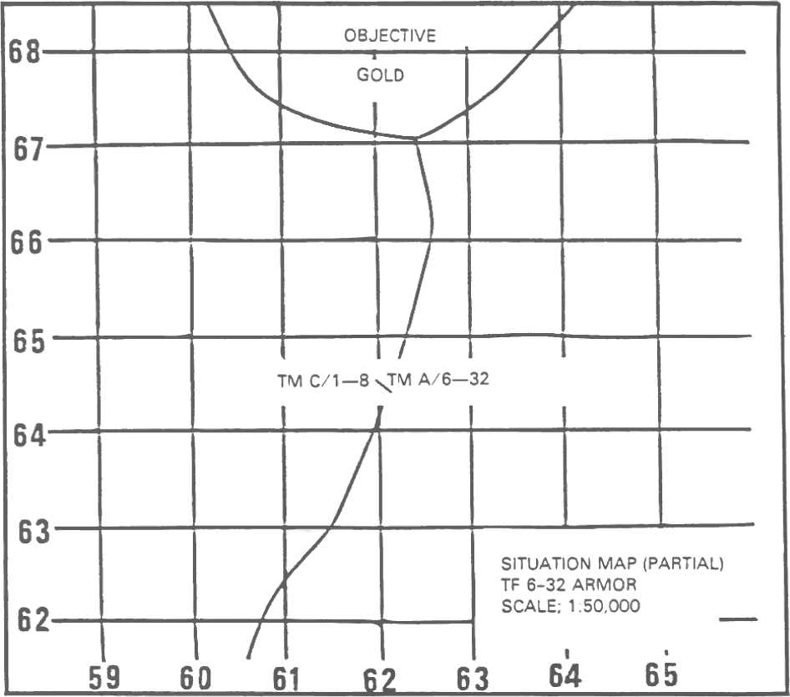

46
CONSOLIDA TED TARGET LIST
LN | TGT NO. | DESCRIPTION | LOCA TION | REMARKS
1
2
3
4
5
6
7

Message to company FSO with Team _______________________: _________________________________
________________________________________________________________________________________________________________________________________________________________________________

47
////////////////////////////////////////////////////////////////////////////////

ANSWERS:

23. a. In plotting the targets on his map, the FSO discovers that both the Team A and the Team C company FSOs have requested fire on the same automatic weapons position. The FSO determines that it is probably closer to Team A than Team C and deletes the Team C target number, as shown below:

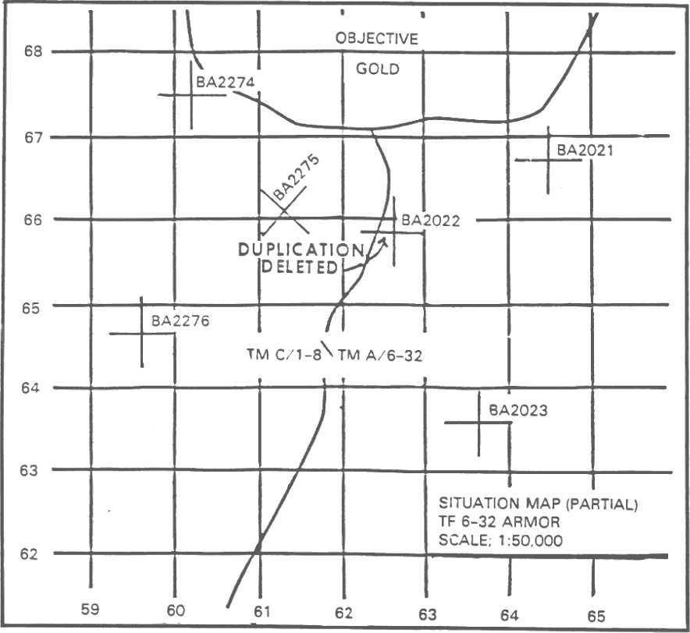

////////////////////////////////////////////////////////////////////////////////

48

b. Message to company FSO with Team C: YOUR TARGET NUMBER BA2277 IS
DELETED; REPLOT AS TARGET BA2022 IN TEAM A SECTOR.

- CONSOLIDATED TARGET LIST

_
LN | TGT NO. | DESCRIPTION | LOCATION | REMARKS
1 | BA2021 | Strong point | 64486675 | On-call
2 | BA2022 | Machine gun | 62606585 | 50% smk
3 | BA2023 | Antitank weapon | 63656355 | Priority
4 | BA2274 | Squad strong point | 60186746 | On-call
5 | BA2275 | Observation post | 61306605 | 50% VT
6 | BA2276 | Antitank weapon | 59606458 | Priority

NOTE:
This target list is forwarded to the DS Bn FDC without delay by the most secure means.

////////////////////////////////////////////////////////////////////////////////

e. Target list work sheet. Initial planning action taken at division artillery tactical operations centers (TOCs) and DS battalion FDCs involves the target list work sheet. The work sheet is used to compile the targets for planning and is the source document for the target list that will be included in the FA support plan. The work sheet is not part of the FA support plan. The data on the target list work sheet aid in determining how each target will be attacked. The work sheet consists of nine alphabetically designated columns and five work columns. The alphabetical column headings facilitate transmission of the data by electronic means. As with other forms, the target list work sheet will be useful only to the degree that the information entered is complete and accurate. The illustration on the following page is an example of a completed target list work sheet.

49
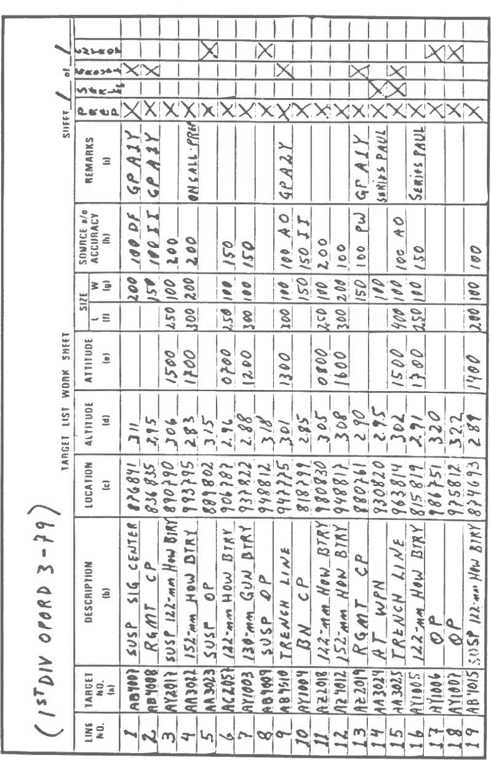

50
- Line number. The line numbers on the target list work sheet are for internal use by fire planning personnel as administrative control measures.

- Target number (a). Each target is assigned a target number from the block of numbers assigned to the planning source that originates the target.

- Description (b). The target description entered in this column should be a concise statement of the nature of the target. The decision on how the target will be attacked (method of fire) is based on this information. The information must be adequate to ensure a sound decision.

- Location (c). Enter grid coordinates to at least 100-meter accuracy (six digits). For a point, rectangular, or circular target, list the center of mass of the target. For a linear target, enter the coordinates of the center point.

- Altitude (d). Enter the altitude of the target, in meters above sea level to the nearest meter, unless otherwise specified. This information facilitates computation of more accurate technical firing data by FDC personnel.

- Attitude (e). Enter the attitudes (relative direction of the long axis) of linear and rectangular targets in grid azimuths.

- Size (f and g). Enter no dimensions for a point target, one dimension (length--f) for a linear target, and two dimensions (length--f and width--g) for a rectangular target. Enter the radius of a circular target in column g.

- Source/accuracy (h). The information in this column aids in deciding how to attack the target. When known, and if not self-evident from the target number itself, enter the source (intelligence report, aerial observer, prisoner of war, etc.) and/or the accuracy of the target data (probable error of target location method when known or reliability of intelligence source).

- Remarks (i). Enter any special planning considerations for attack of the target. The target description may be amplified here if necessary.

- Work columns. These columns are used to indicate targets that are to be included in a particular schedule. Enter one diagonal line (/) under the appropriate column to show the target is to be included in a particular schedule. When the target has been scheduled, enter an opposing diagonal line, forming an X to show the action is complete.

f. Target overlay. The target overlay is a tool to supplement the target list work sheet. It is not published as part of the FA support plan. It is used in conjunction with the fire support situation map to display planned fires in relation to the scheme of maneuver or plan for the defense.

51
As a minimum, it should include the targets to be fired, units to fire, supported unit boundaries, and any fire support coordinating measures in use. The overlay helps- -

- Resolve duplications.

- Evaluate adequacy of planned support in relation to the scheme of maneuver or plan for the defense to allow adequate coverage of the zone.

- Determine the most appropriate unit to attack a given target.

- Identify targets that will require special coordination.

The following illustration of a typical target overlay contains marginal information that identifies the overlay, references the applicable map sheet, and provides orienting data in the form of grid register marks. All targets planned in support of the maneuver battalion or brigade operations are displayed on the target overlay. Target overlays are explained in more detail in Lesson 2 of this subcourse.

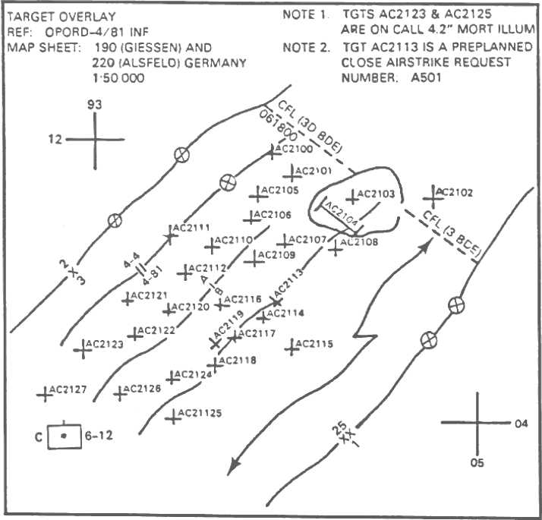

52
g. Target list. The target list is a part of the FA support plan and contains data on targets planned to support the operation. The data are extracted from the target list work sheet and are presented in the format shown in the following illustration. Each target is assigned a line number for administrative control. The Remarks section is used to enter special instructions regarding individual targets, such as implementing or executing instructions for the firing units. A remark entered in this section is keyed to a subscript (note) next to the target number. The target list can be reproduced and disseminated easily.

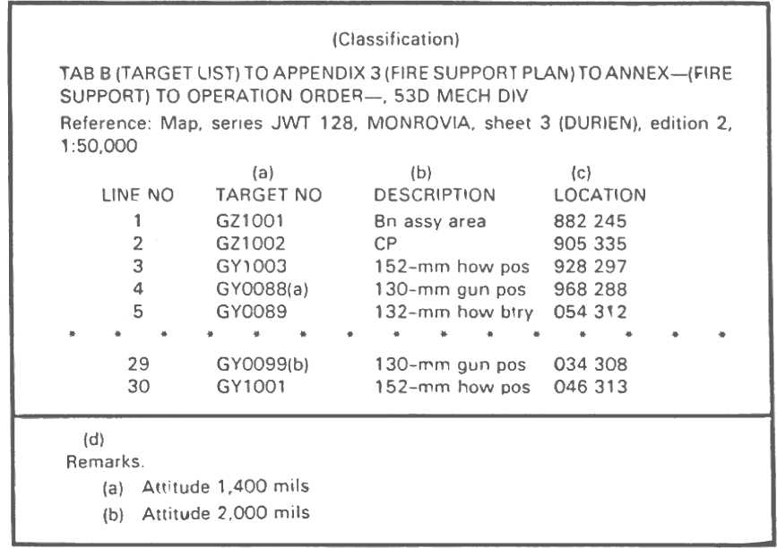

PRACTICE EXERCISES:

24. T F The FSO at the maneuver battalion receives target lists, consolidates targets, and
plots targets on the firing chart.

25. T F The FSO forwards the consolidated target list to battalion FDC as soon as all FIST
target lists are submitted to him.

26. T F The target list work sheet is the S3's source document for fire planning and forms a part
of the FA support plan.

53
27. T F The decision on how a target will be attacked is based in part on information shown in
column (b), DESCRIPTION, of the target list work sheet.

28. T F Targets located by grid coordinates require an accuracy to at least eight digits (10 meters).

29. T F Work columns provided on the target list work sheet are used to identify targets for
scheduling and to show when action has been completed.

30. T F The target overlay is a graphical representation of the target list.

31. T F A typical target overlay contains marginal information that identifies it, the grid register
marks, and the location of all maneuver elements.

32. T F The target lists and target overlays will 'show only planned targets for a given operation.

- T F The target list forms a part of the F A support plan and assigns targets to firing units for
attack.
////////////////////////////////////////////////////////////////////////////////

ANSWERS:

24. F
25. F
26. F
27. T
28. F
29. T
30. T
31. F
32. T
33. F

////////////////////////////1///////////////////////////////////////////////////

25. SUMMARY. The FIST develops targets and assigns targets on the basis of the company/team commander's guidance. Any misunderstandings are avoided and accuracy is promoted when a well-prepared plan can be explained graphically as plotted on the FIST map. The FIST target list is an informal document that contains all information required by the FDC to identify, process, and compute firing data for indicated targets. Finally, the company FSO forwards the target lists to the maneuver battalion FSO by the most secure means available within existing time constraints.

54
Lesson 5
PREPARE A FIRE SUPPORT CAPABILITIES OVERLAY

OBJECTIVE

After completing this lesson, you will be able to prepare a fire support capabilities overlay.

26. INTRODUCTION. Preparing a fire support capabilities overlay can be as simple or as complex as the unit commander desires. Normally, overlays will contain most of the information posted on the situation map. Overlays are usually prepared on acetate or tracing paper and contain some weapon characteristics and also marginal information.

27. FIRE SUPPORT CAPABILITIES OVERLAY. The fire support capabilities overlay shows locations and ranges of all indirect fire weapons that can reach the supported maneuver unit zone of action. These weapons may be mortars, field artillery, or naval guns. The fire support coordinating measures are shown on the overlay and must be accurately plotted and labeled.

28. PREP ARING THE OVERLAY. There are three major steps in preparing a map overlay: orientation of the overlay material, plotting and symbolization of detail, and addition of marginal information.

- Orient the overlay material over the desired area as explained in the previous - lessons.

- Trace the required information on the overlay as explained in the previous lesson. Begin by plotting and labeling all direct support (DS), reinforcing, and general support reinforcing (Gs'R) units, indicating the range for each unit.

- Enter the marginal information on the overlay as explained in the previous lesson.

We are going to prepare a fire support capabilities overlay step by step. We will start with the basic illustration and, as bits of information become available, we will add to the illustration until we have a completed overlay. For this lesson, we used a fire planning template to construct the maximum ranges for supporting artillery and mortars. (If fire planning templates are not available, other means [i. e., RDP, protractor, etc.] may be used as long as they are accurate.) Now, we will begin our preparation of a fire support capabilities overlay.

55

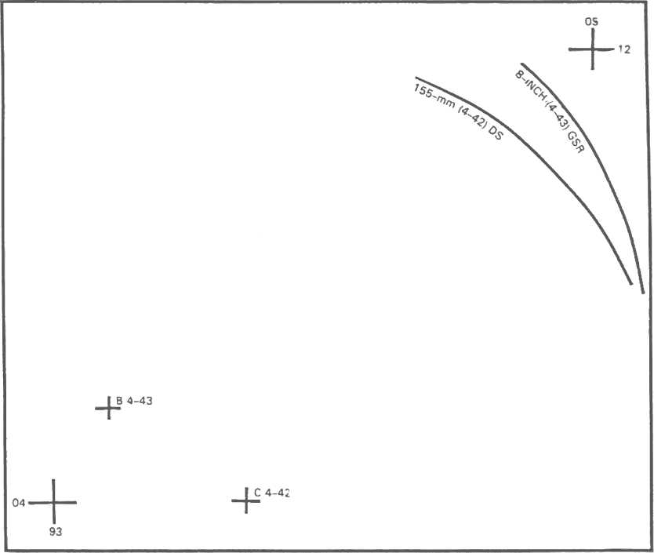

a. In the following illustration, notice that we have located the grid register marks and the DS and GSR batteries. The ranges for the batteries are also shown so that the capabilities of each weapon system are known by glancing at the overlay. The maximum range arc is drawn by using a fire planning template of the appropriate map scale. The vertex of the template is placed on the battery center, and the arc is drawn across the front of the zone of action of the supported unit.

56

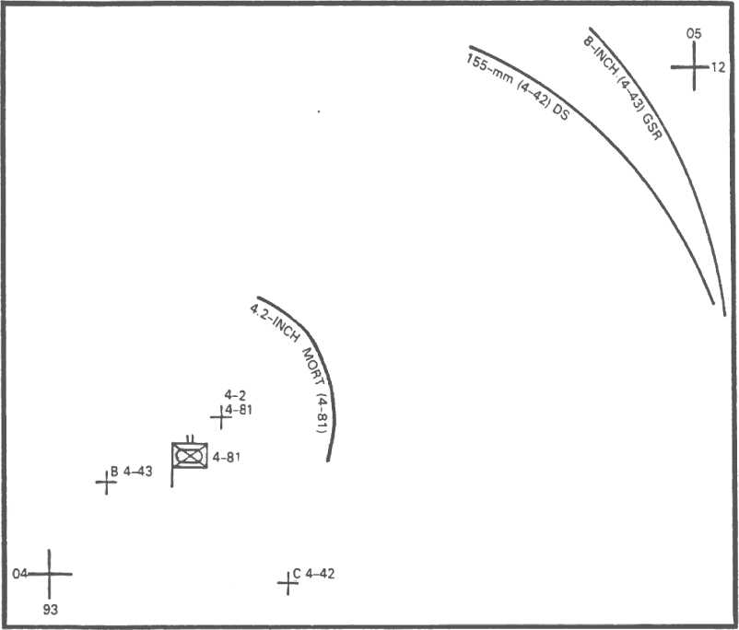

b. After we have plotted the DS and GSR batteries, we will plot the mortars of the maneuver unit. (You may also want to plot the reinforcing field artillery at this time, but for instructional purposes, we will do it later in the lesson.) The following illustration shows the overlay with the mortar unit added along with the maximum range. As for the DS and GSR batteries, use a fire planning template, if available.

57

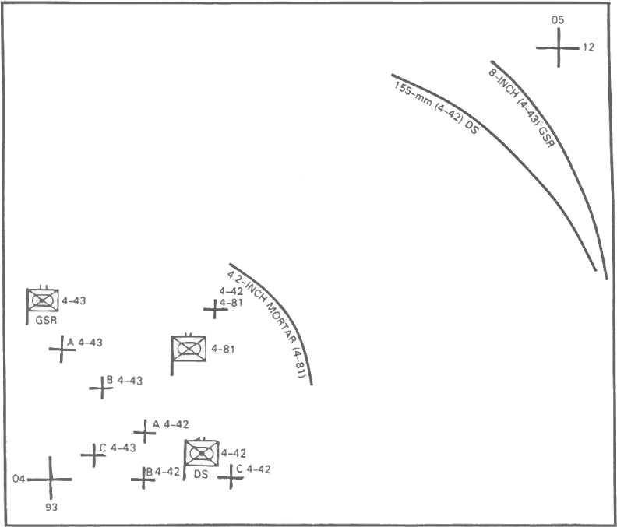

c. Our next step is to plot all other field artillery units including reinforcing units, if any, in the zone of action of the maneuver unit. The range capabilities of the artillery units posted at this time will show on the overlay. If naval gunfire support is available, the maximum range for those weapons will be posted at this time. In the following illustration, we show the additional artillery units. (We do not have naval gunfire support.)

58

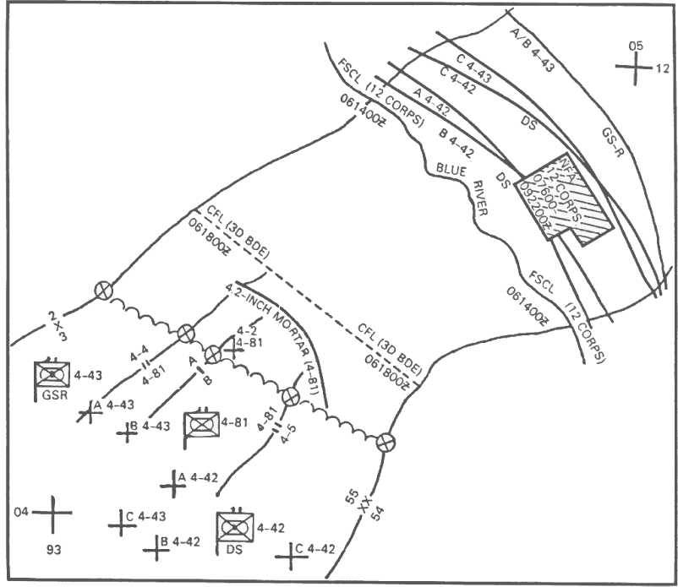

d. After plotting all field artillery, mortars, and naval guns that will support the zone of action of the maneuver unit, we must plot the fire support coordinating measures. We will plot permissive as well as restrictive coordinating measures. Remember, an actual overlay would be drawn with colored pencils or grease pencils.

59

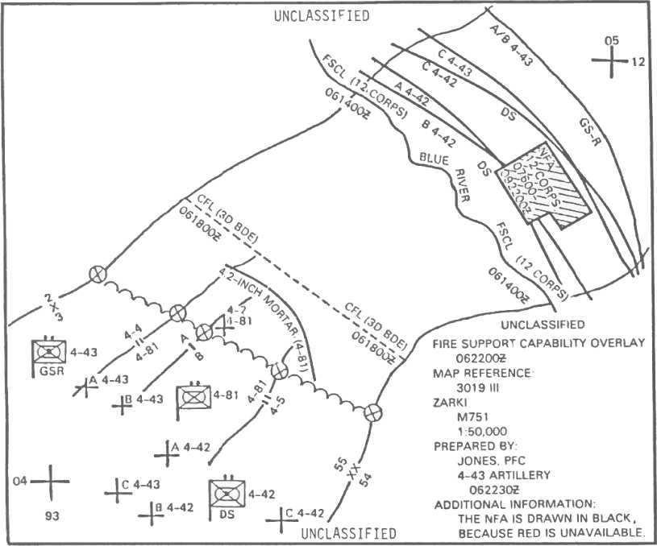

e. The final step is to enter the marginal information and security classification. Remember to enter the title and to be as specific as possible. Don't forget that the date and time are entered twice: the date and time of the information, and the date and time the overlay is prepared. You may also want to include a legend after the PREPARED BY date and time. In the following illustration, the legend has not been used, but we did use the additional information section.

60
SELF-EVALUATION EXERCISES:

3. The fire support capabilities overlay shows the locations and _____________________ of all
indirect fire weapons that can reach the zone of action of the supported maneuver unit.

4. We begin plotting required information on the overlay by plotting and labeling all _________ ,
_________ , and ____________ units, including the range for each unit.

5. The information found in the lower right corner or upper left corner of an overlay is called
_______________ ______________.

6. An actual overlay would be drawn with ____________ ____________ or _______________
______________.

7. If nonstandard symbols are used, a _______________ must be included on the overlay.

////////////////////////////////////////////////////////////////////////////////

ANSWERS:

3. ranges
4. DS, reinforcing, GSR
5. marginal information
6. colored pencils, grease pencils
7. legend

////////////////////////////////////////////////////////////////////////////////

29. SUMMARY. In preparation of a fire support capabilities overlay, it is helpful to remember the three major steps: orientation of material, plotting and symbolization of detail, and marginal information. Also, keep in mind that ranges of DS and GSR batteries are shown so that the capabilities of each weapon system are known simply by glancing at the overlay. Plot all mortars and naval guns and post maximum range of naval guns. Finally, remember that an actual capabilities overlay will be drawn with colored pencils or grease pencils with the date and time entered twice: date and time of information and date and time prepared.

61
FA 4203-6
Sep 86
EXAMINATION

FIRE SUPPORT TARGET LISTS, STATUS CHARTS,
SITUATION MAPS, AND CAPABILITIES OVERLAYS

This examination consists of 25 questions. Answer all questions on the enclosed ACCP Examination Response Sheet (TSC Form 59). Individual work on the exam is mandatory. After completing the examination, place the answer sheet in the self-addressed envelope provided and mail it to the Institute for Professional Development (IPD) for grading. IPD will send you a copy of your grade for this examination.

NOTE: Use the following situation for questions 1 through 4:

SITUATION: You are preparing your target list. You have developed the following targets and plotted them on your map:

Target Number AB0101: 122-mm G/H battery at grid 976205. You know that the normal area size for this type of unit is 200 by 300 meters. The attitude of the target is 1,200 mils.

Target Number AB0102: A rifle company in a reserve assembly area at grid 952193. The target area is circular with a 200-meter radius.

Target Number AB0103: A trench line from grid 981181 to 986181.

Target Number AB0104: An OP with overhead cover at grid 972185.

1. Which symbol would you use to plot target number AB0101 on your map?
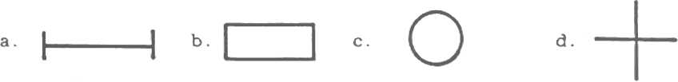

2. Which symbol would you use to plot target number AB0103 on your map?

E-1
3. Which is the correct entry to list target number AB0102 on your target list?

TARGET LIST
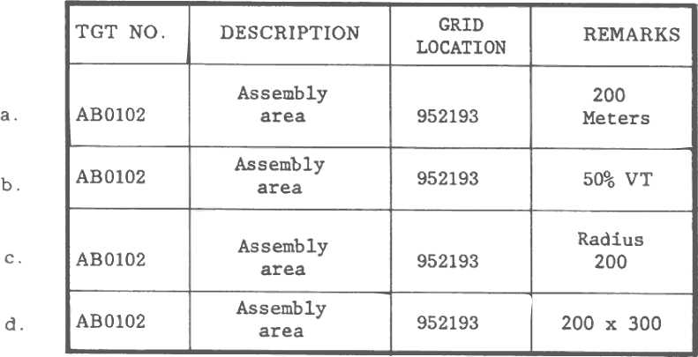

4. Which is the correct entry to list target number AB0104 on your target list?

TARGET LIST
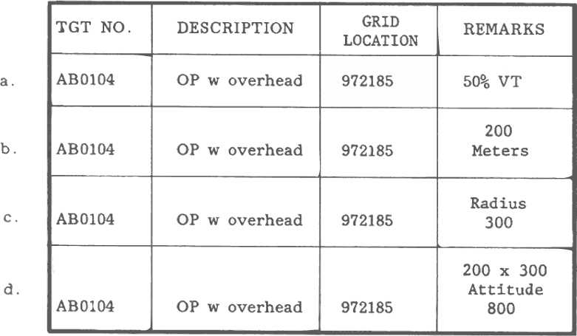

E-2
5. Which is the best way to submit your target list to the FIST?

a. Hand-carry it.
b. Use wire communications.
c. Use FM radio communications.
d. Use AM teletype communications.

6. Which is the correct basic symbol for a unit?

7. Once pertinent information to be placed on the fire support status chart has been identified, the
FSO must realistically evaluate his ability to--

a. formally brief the commander on its meaning.
b. transport the chart during tactical movements.
c. provide adequate fire support to the maneuver element.
d. obtain this information on a timely basis.

8. Boundaries between units are marked with--

a. solid green lines.
b. solid black lines.
c. solid red lines.
d. dashed black lines.

9. Which is the correct symbol for a coordinating point?


10. While the size and format of the fire support status chart are not prescribed, the FSO who
maintains the chart must ensure that--

a. it will fit in his pocket.
b. it reflects the most current fire support information.
c. the commander approves of the style.
d. the division artillery S3 has a copy.

11. Permissive fire support coordinating measures are drawn on overlays and maps in-

a. black.
b. red.
c. green.
d. three dimensions.

E-3
12. The legend on an overlay is necessary only when

a. the author is unknown.
b. the time the overlay was drawn is unknown.
c. nonstandard symbols are used.
d. a map reference is unnecessary.

13. The classification of the overlay is shown

a. on the top and bottom of the overlay and on top of the marginal information section.
b. on the left, right, and top of the marginal information section.
c. on the top and bottom of the overlay.
d. only if the overlay is classified.

14. The fire support capabilities overlay shows the location and

a. size of each enemy unit.
b. type of enemy materiel available for destruction.
c. positions of enemy observation posts.
d. ranges of all indirect fire weapons supporting the maneuver unit.

15. Information on the fire support situation map is always shown in relation to- -

a. the tactical situation.
b. prominent terrain features.
c. defensive plans.
d. organic weapons capabilities.

16. When a weapon symbol appears on a map or overlay, the base of the shaft indicates the- -

a. location of the weapon.
b. size of the weapon.
c. number of weapons at the location.
d. direction that the weapon is firing.

17. The colors that represent both friendly and enemy man-made obstacles or contaminated areas
are - -

a. black and blue.
b. yellow and green.
c. yellow and red.
d. green and red.

E-4

18. To preclude cluttering up the fire support situation map and aid in briefing commanders and
staff, the FA fire support planner may construct a separate- -

a. visibility diagram.
b. terrain sketch overlay.
c. F A range capabilities overlay.
d. enemy capabilities overlay.

19. The FA weapons and range capabilities overlay normally includes the location of- -

a. DS FA batteries.
b. GS and GSR FA units.
c. maneuver battalion organic 107-mm mortars.
d. all of the above locations.

20. Which is the correct unit size symbol for a squad?

21. One type of information that the FIST may transmit in the clear is information on the- -

a. observer's location.
b. results o{ friendly fires.
c. accuracy and damage done by enemy fires.
d. supported units time/plan of attack.

22. Overlays are used in conjunction with the basic fire support situation map to- -

a. reduce cluttering.
b. highlight priority considerations.
c. keep information organized.
d. accomplish all of the above.

23. The FIST submits information reports that are frequently the most accurate and timely source
of- -

a. information on friendly activity within the command.
b. battlefield information available to the force commander.
c. intelligence available to higher echelons.
d. information on enemy order of battle.

E-5
24. The artillery fire planning documents prepared by a company FSO to support a maneuver
company operation normally consist of a- -

a. target list.
b. target overlay and a target list.
c. target list, a target overlay, and a written portion.
d. target list, a target overlay, a written portion, and one or more fire support schedules.

25. The FA commander's guidance on how to accomplish the FA portion of the fire support plan- -

a. prescribes the amount of detail used in fire support planning.
b. designates specific units to attack critical targets.
c. is not concerned with the manner in which targets will be engaged.
d. is taken from the oral portion of the division OPORD.

E-6

